**Forest fire detection**

1. **What is Deep Learning?**

* Deep learning mimics neural networks of the human brain.
* It enables computers to autonomously uncover patterns and make informed decisions from vast amounts of unstructured data.
* Deep Learning is transforming the way machines understand, learn, and interact with complex data.
* Deep Learning is a type of machine learning that uses structures called artificial neural networks to learn from large amounts of data and make decisions or predictions.
* It’s called "deep" because these networks have many layers between the input and the output, allowing them to learn complex patterns.

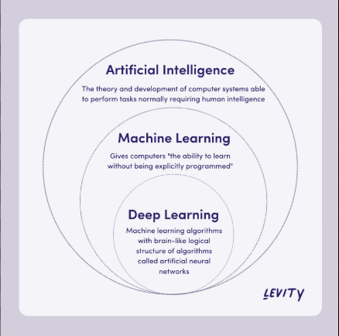

**Deep learning applications**

Deep learning can be used in a wide variety of applications, including:

* Image recognition: To identify objects and features in images, such as people, animals, places, etc.
* Natural language processing: To help understand the meaning of text, such as in customer service chatbots and spam filters.
* Finance: To help analyze financial data and make predictions about market trends
* Text to image: Convert text into images, such as in the Google Translate app.

1. **What is Neural Network and its types ?**

* A neural network is a machine learning model inspired by the structure and function of the human brain.
* A neural network is a computational model inspired by the human brain, consisting of interconnected nodes (neurons) that process information.
* These models are designed to mimic how the human brain processes information.
* They use interconnected nodes (artificial neurons) organized in layers to process data.

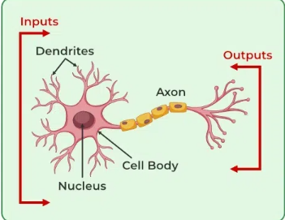

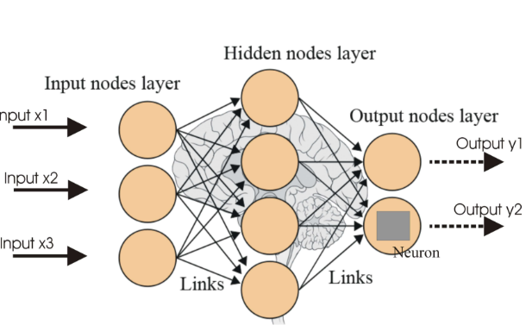

**Types of Nural Network**

* 1. **Convolutional Neural Networks (CNNs)**

CNNs are designed for processing grid-like data, such as images, and are particularly effective for tasks like image recognition and object detection.

* 1. **Recurrent Neural Networks (RNNs)**

RNNs are designed for processing sequential data, such as time series or natural language, and are useful for tasks like language modeling and speech recognition.

* 1. **Artificial Neural Network(ANNs)**

ANNs are designed to process information in a way that resembles how biological neural networks work, using interconnected nodes (artificial neurons) to learn from data and make predictions.

**3. What is CNN in simple words .**

* CNN stands for Convolutional Neural Network.
* It is a special type of neural network mainly used to process images.
* A CNN is a deep learning model that automatically detects patterns, shapes, and objects in images to help classify or recognize what’s in the image.
* It is a specialized class of neural networks designed to process grid-like data, such as images**.**
* They are particularly well-suited for image recognition and processing tasks.

**Applications of CNN**

* **Image classification**: CNNs are the state-of-the-art models for image classification. They can be used to classify images into different categories, such as cats and dogs, cars and trucks, and flowers and animals.
* **Object detection**: CNNs can be used to detect objects in images, such as people, cars, and buildings. They can also be used to localize objects in images, which means that they can identify the location of an object in an image.
* **Image segmentation**: CNNs can be used to segment images, which means that they can identify and label different objects in an image. This is useful for applications such as medical imaging and robotics.
* **Video analysis**: CNNs can be used to analyze videos, such as tracking objects in a video or detecting events in a video. This is useful for applications such as video surveillance and traffic monitoring.

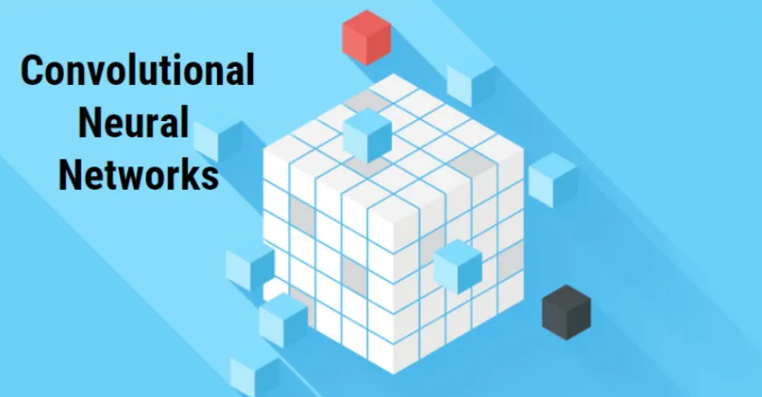

* 1. **Write a short note on Pipeline**
* It is a sequence of interconnected steps that automate and streamline the process of building, training, deploying, and maintaining machine learning models.

1. **Data Collection & Data Loading**

We collect the data from Kaggle.com as its size is almost 11GB so we need to make the API call from the website .

API can be understand as it the medium to communicate between server and client .

The data set has 3 directories

* + 1. Train
    2. Val
    3. Test
* So , First we train the model with image then validate the model and then we test the model
* Every directories have 2 sub category that is fire and no fire

1. **Image Processing / Image Augmentation**

* The process of shaping the image into particular size is called image processing.
* Example if we have two images with different dimensions then we need to convert it into the particular dimension .
* It is a process of creating multiple copy of image by performing operation like rotating , flipping , zooming is called image augmentation .
* To build the CNN model we use library i.e. Tensorflow.

